**Application example for classification of the segmented regions**

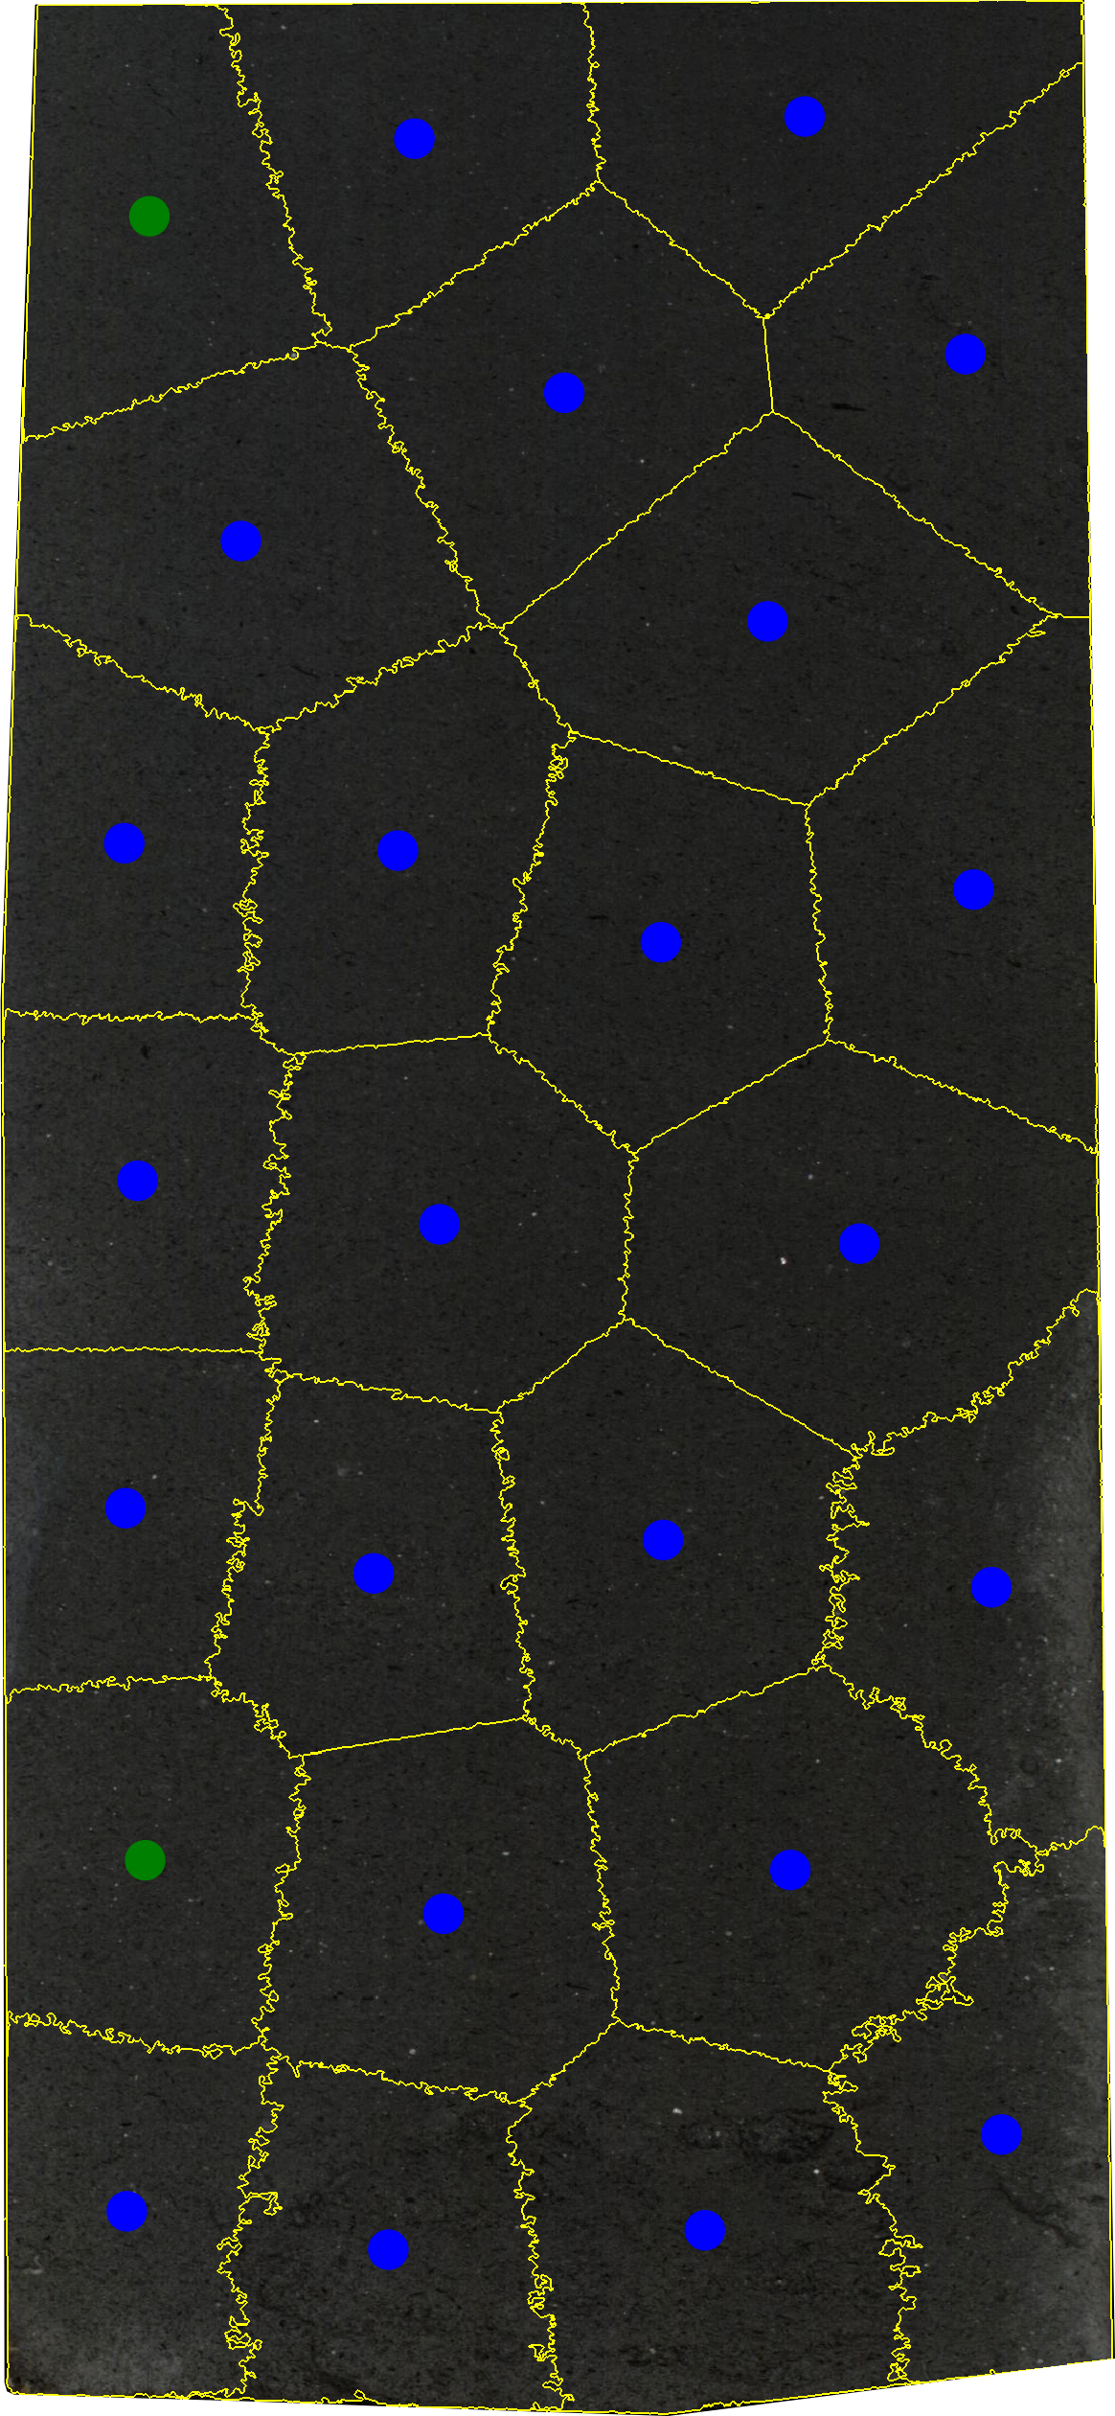

Figure 1 Classification of the segmented regions for the image: 362-u1480g-52r-3-a; region-1; Fine-sand_sandstone.png, lithology: Fine sand/sandstone, total segmented regions: 25, combination training and testing: 90%Train – 10% Test, Apx: 71,48 cm².

Table 1: Caption for classification segmented region.

|  |  |
| --- | --- |
| **Caption:** | **Description (action):** |
|  | Training |
|  | Test with correct classification |
|  | Test with incorrect classification |